Please note that the steps that I listed below that trigger errors do not have consistent results. Sometimes it works, and sometimes it generates errors.

Create a new project using the Visual Studio 2022:
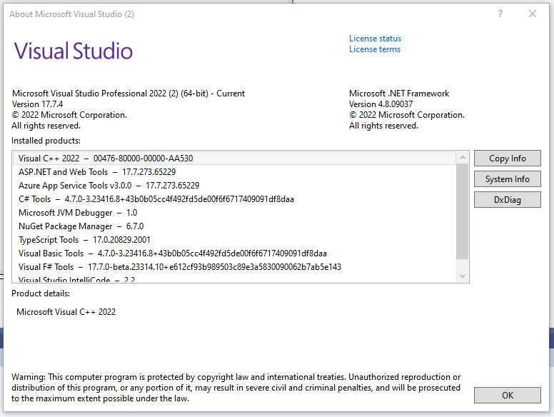
Dragging UA Connectivity from Toolbox:
Several windows pop up installing package…
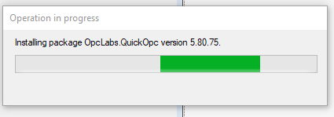
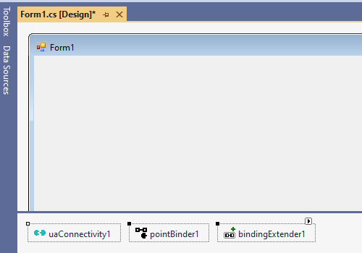
- Dragging a label from Toolbox.
- Right-click label1 and then click on “Bind to Point…”
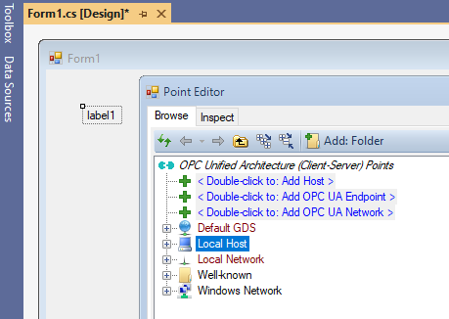
- Double click “Add OPC UA Endpoint” then entered “opc.tcp:\\###-##-KEPWARE.#######.COM:49320”
  - # are replacement characters for security reasons.

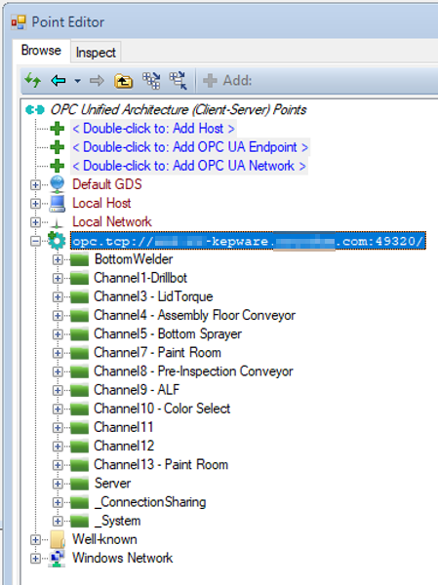

- Selected a field and click Ok.
- Clicked Save All.
- Closed Visual Studio 2022.
- Open the project in Visual Studio.
- Drag a label to the form.
- Right-click label2 and click “Bind to Point…”
Worked well without problems like step 1 to 3.
- Saved all then close Visual Project.
- Open the same project
- Right click label2 and click “Remove Live Bindings” then click “Bind to Point” … Worked!
- Right click label2 and click “Bind to Point…” Error as shown below popped up. After this error, when I create a new label, and then right click “Bind to Point,” the same error will pop up.
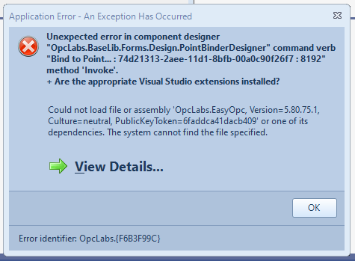
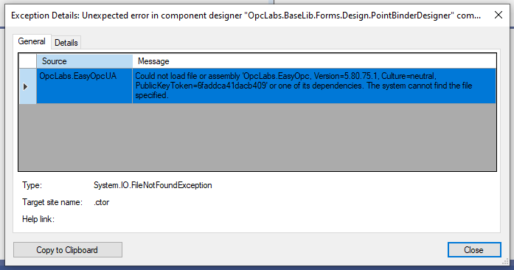

- Click “Edit Live Binding…” from Properties panel and select the point binding and click “Remove” button. Then click “Bind to point” from the Properties panel … The error pops up.
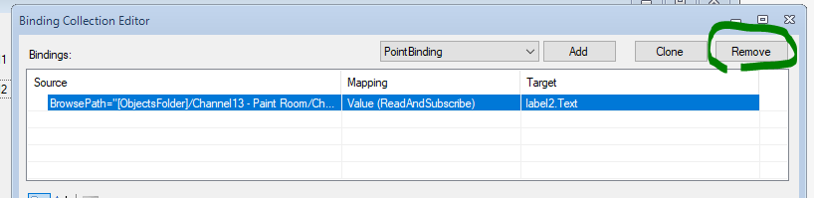
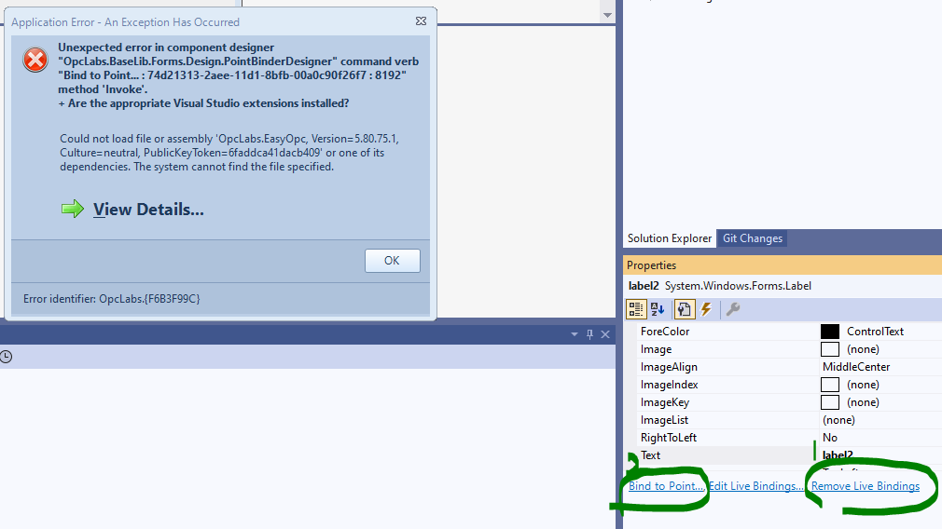

After clicking OK on the error popup and clicking the x to exit Visual Studio, the popup as shown below appears, and I need to Ctrl-Alt-Del and then click end-task of task manager to close project.
